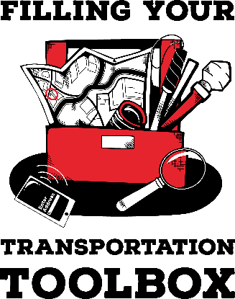

ACTIVITY GUIDE: Transportation Trivia

- Q: When walking on a road with no sidewalk, where should you walk?
A: Facing traffic (on the edge of the roadway) so you can see cars coming.
- Q: You’ve hired a driver and now call to arrange your first ride. What are two things you need to tell the driver?
A: Where you are at, the address where you are going, what time you need to be picked up
- Q: Texting while walking makes you significantly more likely to get into an accident. Why?
A: Looking at your phone while walking (especially crossing streets) increases your risk of falls or collisions.
- Q: What is the most effective way to be seen by drivers at night?
A: Wearing reflective materials. Contrary to popular belief, white or bright-colored clothing is often not enough for drivers to see you in time to stop.
- Q: Why is it crucial to wear a seatbelt even if you're in the back seat?
A: Unbuckled passengers can be thrown forward, hitting other passengers or the front seats, and airbags can be dangerous for unbuckled adults near the dashboard.
- Q: When riding a bicycle in the street, should you travel with or against the flow of traffic? Why?
A: With traffic (on the right side of the road). Bicycles are considered vehicles and must follow the same rules as cars.
- Q: Name three expenses for someone who owns a car?
A: gas, car payment, registration, maintenance, insurance
- Q: What question should you ask an Uber (rideshare driver) before getting in the vehicle?
A: Who are you picking up?
- Q: If you're riding with a driver who's speeding or being reckless, what's a smart thing to do?
A: Ask them to slow down or ask to get out at a safe spot and find another ride.
- Q: What is the purpose of going through the TSA checkpoint at the airport?
A: To ensure travelers are not bringing anything dangerous on board the airplane.
- Q: If you can’t see when a taxi or Uber (rideshare) arrives to pick you up, what is something you can do so that the driver won’t leave without you?
A: Send the driver a note and tell them you can’t see, ask the driver to text or call you when you arrive, describe what you’re wearing and ask the driver to find you.
- Q: List three apps you might use when traveling.
A: Seeing AI, Aira, Be My Eyes, Google maps, Apple maps, etc.
- Q: If you do not know exactly where a business is located in a block, how can you get this information?
A: Use a map app, call the business and ask questions, seek assistance from a pedestrian.
- Q: How can you find out what time the #7 bus will arrive at the bus stop at the intersection of 1st and Main Street?
A: Call the bus company, look online at the bus schedule, use the bus company’s app to look at the schedule

Q: Why do you need strong O&M skills to be a successful guide dog user?
A: You have to direct the dog and make decision about when it is safe to cross streets. You also have to locate businesses or other buildings. There may be times when you opt no to take your dog or your dog is sick, and you will need to travel without a guide dog.
TIE BREAKER: List as many forms of transportation you can think of in a minute. The team who has a form of transportation that the other team does not have gets a point.

