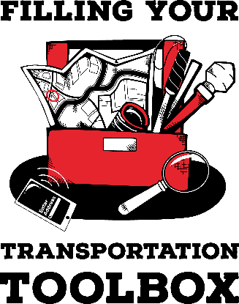

ACTIVITY GUIDE: Working with Drivers

Goal: Travelers will become familiar with the different types of drivers and considerations for working with each type of driver.

Materials:
- None

Directions for Leader:
- Lead a discussion about the different types of drivers active travelers may encounter.
  - Hired drivers (taxis): Taxis are typically owned by a company. Travelers may call, use an app, or go to a designated area (e.g., at the airport) to get a taxi. Typically there is a pick up fee plus a per mile fee. Many people tip taxi drivers.
  - Uber/Lyft: Rideshare services provide door-to-door transportation. Rides are requested through the company’s app. Rides can be requested ahead of time or when needed. Rideshare companies have safety features in their apps that travelers may wish to use. Fees may vary throughout the day depending on the number of available drivers and traffic. Travelers can tip the driver through the app.
  - Carpools: Sometimes groups form carpools, for example members of a church who travel together to church or employees at a company who travel together to work. Each member of the carpool contributes money to pay part of the cost. Some carpool members may take turns driving while others contribute in different ways, for example bringing snacks or cleaning the vehicle.
  - Rides with Family Members, Friends, or Co-Workers: People the traveler know may offer them rides or the traveler may ask those they know for rides. The traveler needs to pay attention to ensure they are not taking advantage of someone. The traveler can reciprocate for rides by babysitting, pet sitting, watering plants, teaching the driver how to play an instrument, etc. The traveler may be asked to pay for the ride or gas. Even if payment is not expected the traveler should offer to pay or do something to assist the drive.
  - Hired Drivers: The traveler may advertise for and hire a driver. The traveler should consider how much they want to pay the driver, who is responsible for the cost of gas and tolls, who plans the route, what the driver does while the traveler is engaged in activities (e.g., work meeting, shopping), and what would lead to the driver being fired.
- Discuss with travelers ways to advertise for a driver.
- Have travelers generate a list of questions to ask a potential driver during an interview.
- Discuss driver and passenger responsibilities.
- Discuss safety when in vehicles being driven by others especially individuals the traveler does not know.
- If time allows, have travelers role play interviewing a potential driver.

Directions for Travelers:
- Think about the different types of drivers there are in your community. For example, you may have a family member who drives you to and from school or you may be in a carpool for your sports team.
- As a group let’s generate a list of different types of drivers and what you know about each type of driver.
- How do travelers find drivers?
- If you were interviewing someone who you hope to hire as a driver, what questions would you ask them?
- Let’s role play hiring a driver. Pair up with another traveler or staff member and each take a turn being the traveler and the potential driver.

