

Tech and Outdoor Travel
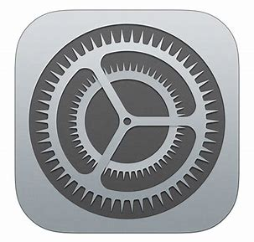

Configure Device Settings
- Accessibility; Zoom
    - Zoom: ON
    - Zoom Region: Full Screen Zoom
    - Use a three-finger triple tap to turn Zoom on/off.
    - Adjust magnification using the slider at the bottom of the Zoom menu.
    - Use 3 fingers to move around on the screen.

- Accessibility; Accessibility Shortcut (located at the bottom of the menu)
    - Items selected here are activated/deactivated by triple-clicking the side button.
    - Select VoiceOver
    - Select Speak Screen


Weather App
- Ask Siri to open the Weather app
- Triple tap the side button to open Accessibility Shortcuts
- Select Speak Screen to listen to the weather in your location.
  - What is the current temperature?
  - What will be the high temperature today?
  - Is rain expected today? If so, what time?
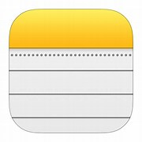
- Take a screenshot of the forecast and share it to Notes.
- In the white space beside the image, type or dictate the title for today’s log: Outdoor Travel Log.
- Save this as a new note. You will add to this note throughout the day and then share it with Dr. Penny by text.

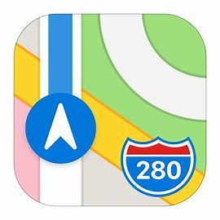
Maps (Apple Maps)
- Open the Maps app
- In the search field enter: Hopelands Gardens
- A page will open with a car icon on the left side that shows the travel time. From this page, you can also visit the location’s website and check its hours.
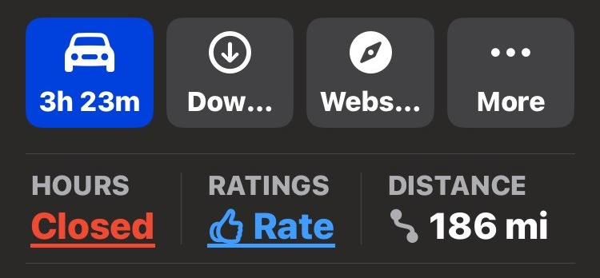

  - Below the car icon, select HOURS.
  - What hours will the park be open today?
- Exit the HOURS screen and select the car icon. This will give a route and travel time by car.
- Below the map, in the middle of the screen, there are options to the left of the car icon for: walking, public transit, biking, and rideshare.
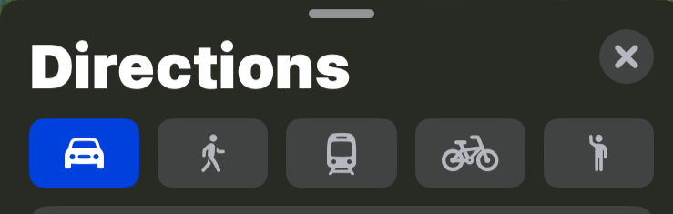
  - How long will it take to drive to this location?
  - How long will it take to walk to this location?
  - Could you take public transportation to this location?
- Open your Outdoor Travel Log and record the information you found for traveling to Hopelands Gardens. You can type, dictate, make a voice recording, or share a screenshot. Include the following information:
  - The app you used
  - The location you selected
  - The best method of travel.
  - How long the route will take.
  - The hours the location is open today.
*In your phone Settings; Apps; Maps, you can select your preferred default method of travel (driving, walking, transit, biking).


Google Maps
- Open Google Maps
- In the search box, you can enter an address or the name of a location.
- On the right side of this box is a colored circle with a letter. Tap this circle to open a menu. Select Settings.
- In Settings, select Navigation
  - Access your Assistant with “Ok Google”: ON
  - Save parking location: ON
  - Walking Options: Live view: ON
  - Walking Options: Detailed voice guidance: ON
- Below the search box, there is a horizontal row of categories. Select “Coffee”.
  - What is the closest coffee shop?
  - Select this shop and use Speak Screen (triple tap side button) to listen to the drive time, shop hours, and other information.
- Select the blue Directions option below the coffee shop name and information. This will open a horizontal list of travel options.
  - Select Walk
  - Select Start and you will hear walking directions.
  - Select Exit
- Open your Outdoor Travel Log and record the information you found including:
  - The app you used
  - The nearest coffee shop
  - The walking time from your location

Share your Outdoor Travel Log with Dr. Penny by text

Dropping a Location Pin
It's easy to tell a friend where to meet you if you're at a location with an actual address. But what if you're trying to find each other in a huge park or on a college campus? Or maybe you are worried you will not remember where your car is parked? Dropping a pin lets you save a location so you can easily navigate back to it. You can also share it with others.

Dropping a Pin in Apple Maps
      - Enter your home address in the search field.
      - Scroll to the bottom and select “Pin”.
      - To pin your current location, go back to the search page and enter: current location.
      - Select “Mark My Location”
      - Scroll to the bottom of the screen and select “Pin”.
      - Go back to the main page and below the search box, in the Library section, select: Places; Pinned. You will see both of your pinned locations.
      - You can get directions to the location by selecting it.
      - You can share or delete your pin by slowly sliding the pin to the left.
        - Share one of your pins with Dr. Penny by text.

Dropping a Pin in Google Maps
- Enter your home address in the search field.
- Your address will be shown as a red marker on the map. Long press this marker to drop a pin.
- To pin your current location, go back to the search page and long press the blue location marker on the map that shows your current location.
- After you drop a pin, a Dropped Pin menu will appear at the bottom of your screen. Share your dropped pin with Dr. Penny by text.
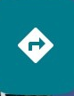
- To navigate to a saved pin, select the right arrow on the bottom of the map screen and select a pin.
Debrief Questions:
- What is something new you learned about Apple Maps?
- What is something new you learned about Google Maps?
- Which of the navigation apps do you prefer? Why?
- What is an example of a situation where dropping a pin could be helpful?
- If you would like to visit a nearby restaurant, what are some advantages of using the category search feature in Maps or Google Maps?

