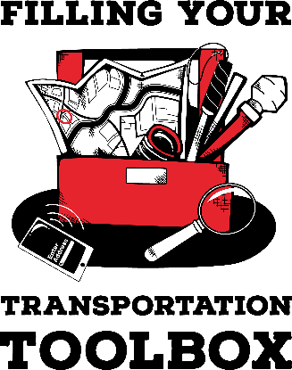

Technology Log
Name
What device did you use?
Android phone
iPhone
iPad
Other
What apps or tools did you use?
Aira
Be My Eyes
Camera
Google or Apple Maps
Lyft
MyAT (Augusta)
Seeing AI
Transit App (Columbia)
Uber
Weather
Other
What kinds of information did you access? For example, did you read a sign, locate the name of building or read a menu?

