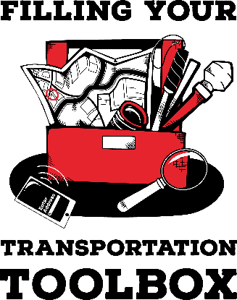

The Cost of Transportation

Directions:
How much does it cost a month to own and operate a vehicle? Your job is to find out the answers to questions below from at least one person. You can ask someone in your family, a friend, or a staff member at the Filling Your Transportation Toolbox program. Be prepared to share the information with the group on Friday.

- What is the name of the person you interviewed?

- What type of vehicle (e.g., car, truck, motorcycle) do they own?

- What is their monthly payment? If they say they do not have a monthly payment, ask them how much they paid each month before paying off their vehicle.

- How much do they pay for insurance every 6 months?

- How much do they pay for registration each year?

- How much do they estimate they pay for gas each month?

- How much do they estimate they pay each month for repairs?

With the information you gathered, estimate how much the person pays each month to own and operate their vehicle.

