Instructions for a Penguin
By Edith West
(18 Rows, 24 Cells)
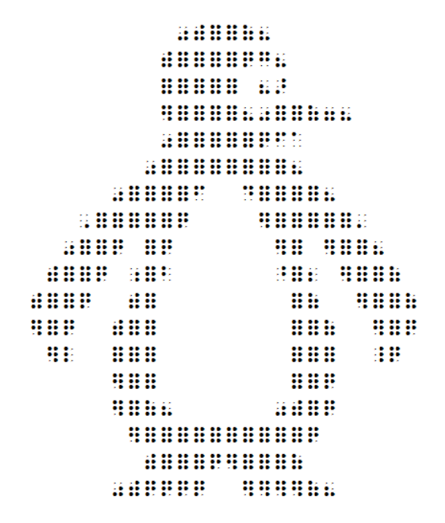
Row 1: Space 11 times, make “was”, make “with”, make 2 full cells, make “of”, make “his”.
Row 2: Space 10 times, make “with”, make 4 full cells, make “q”, make “g”, make “his”.
Row3: Space 10 times, make 5 full cells, space 1 time, make “his”, make “ar”.
Row 4: Space 10 times, make “er”, make 4 full cells, make “his”, make “was”, make 2 full cells, make “of”, make “gg”, make “his”.
Row 5: Space 10 times, make “was”, make 5 full cells, make “q”, make “f”, make “his”.
Row 6: Space 9 times, make “was”, make 8 full cells, make “his”.
Row 7: Space 7 times, make “was”, make 4 full cells, make “f”, space 2 times, make “d”, make 4 full cells, make “his”.
Row 8: Space 5 times, make dot 6, make 5 full cells, make “q”, space 4 times, make “er”, make 5 full cells, make dot 3.
Row 9: Space 4 times, make “was”, make 2 full cells, make “q”, space 1 time, make 1 full cell, make “q”, space 6 times, make “er”, make 1 full cell, space 1 time, make “er”, make 2 full cells, make “his”.
Row 10: Space 3 times, make “with”, make 2 full cells, make “q”, space 1 time, make cell (5,6), make 1 full cell, make “b”, space 6 times, make cell (4,5), make 1 full cell, make “bb”, space 1 time, make “er”, make 2 full cells, make “of”.
Row 11: Space 2 times, make “with”, make 2 full cells, make “q”, space 2 times, make “with”, make 1 full cell, space 8 times, make 1 full cell, make “of”, space 2 times, make “er”, make 2 full cells, make “of”.
Row 12: Space 2 times, make “er” make 1 full cell, make “q”, space 2 times, make “with”, make 2 full cells, space 8 times, make 2 full cells, make “of”, space 2 times, make “er”, make 1 full cell, make “q”.
Row 13: Space 3 times, make “er”, make “L”, space 2 times, make 3 full cells, space 8 times, make 3 full cells, space 2 times, make cell (4,5,6), make “q”.
Row 14: Space 7 times, make “er”, make 2 full cells, space 8 times, make 2 full cells, make “q”.
Row 15: Space 7 times, make “er”, make 1 full cell, make “of”, make “his”, space 6 times, make “was”, make “with”, make 1 full cell, make “q”.
Row 16: Space 8 times, make “er”, make 10 full cells, make “q”
Row 17: Space 9 times, make “with”, make 3 full cells, make “q”, make “er”, make 3 full cells, make “of”.
Row 18: Space 7 times, make “was”, make “with”, make “q” 4 times, space 2 times, make “er” 4 times, make “of”, make “his”

