Step 1: Clarify the student(s) goal/objective/benchmark for instruction.
(Jay Hiller, 10-17-19 working with 18 year old deaf-blind student)
Student A goal/benchmark/objective(s): By April 2020, given direct instruction, a group of peers and a structured activity, CAL, G. will effectively negotiate with peers with decreasing amounts of adult support in 3 out of 5 opportunities.
Note: I use the playing with words technique to practice skills that the student can use later in the week during group instruction in her English Language Arts class. The specific way I work on the goal in the 1:1 sessions is I engineer situations in which the story characters will have to negotiate.

Step 2: Determine whether or not each of the six essential components is included in your plans. Note: if not, why is it not included?
Six Essential Components |  | How is the component included in the planned activity?
 | - Builds on student’s strengths and interest, opportunity for choice-making | This student has been working on this particular story since September 2017. As of this writing, its 804 pages long (36 point, single spaced.) She loves it. Recently, when my computer was acting up, she pulled out an accessory version of the story that she had been working on independently on her ipad during her free time and offered to share it with me.
 | - Includes peers in the interaction | No, unfortunately. I have tried to engage the student with a near aged peer from the community. They did this together one time . It was beyond my wildest dreams successful and I thought I had things set up for them to continue it over the summer. For reasons that aren’t entirely clear to me, it fell through. I’m in the process of getting a college aged volunteer to come do this with us. Because of the characteristics of the TSBVI student body, it’s just been hard to find a good match for this among the other students.
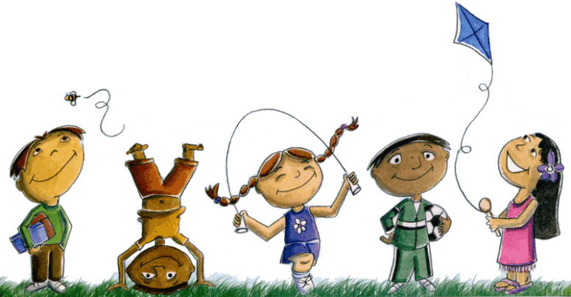 | - Creates an atmosphere of play (social and/or symbolic) with modeling and encouragement | Yes, this is fun for both of us. My sister, also an educator, is fond of saying that teaching is about relationships. This activity has played a key role in my formation of a relationship with this student. When we’re working on this together, there’s a feeling of shared activity and shared enjoyment.
 | - Provides a context for activity through predictable routines, consistent and accessible locations, adequate space for enactment and story creation | Predictable routine: The writing process itself is predictable because we’ve done this together for 3 years. Consistent and accessible locations: always my office. Adequate space for enactment: We haven’t done much of that. Every once in a while to help her understand what I mean we’ll act something out. But that’s few and far between.
 | - Includes the use of props and actions and physical enactment | The only prop we have is the laptop, which I think functions the way a talking stick would. I remember in the very early stages of this, when I felt pretty desperate to set up a connection between me and G., she tried to pass the computer to me, and I made a silly face and passed it back to her. We did this two or three times. I remember this clearly because of the way she looked at me. I think at first she didn’t understand and then (I think) she understood that I was playing with her.
 | - Adult is flexible and supportive and provides scaffolding between highly directive and participatory role and non-directive encourager and scribe. | It’s hard to be objective about yourself, which is why videoing is a good idea. My opinion is that most of the time I strike a good balance between these things.

