Six Essential Components of Play-Based Story Creation
  - Planning

Planning the Activity
This tool is meant to help you think through aspects of your instruction before the lesson takes place. It is not your lesson plan, but hopefully if you develop a practice of thinking about the Six Essential Components as you develop these instructional activities, you will feel more confident and see better results for your student(s).

Just a note, you may have peers included in a story-writing activity; you will not necessarily be focused on instruction with these peers. Their role is to provide opportunities for social interaction and emotional support for the focus student.

Sometimes, though, you may have instruction targeted for more than one student within the writing activity. It is helpful to be clear about what each of your student’s goals or benchmarks/objectives are and how different instructional strategies may be needed for each of these students.

Step 1: Clarify the student(s) goal/objective/benchmark for instruction.
Goal/benchmark/objective(s) for student (s):

Step 2: Determine whether or not each of the six essential components is included in your plans. Note: if not, why is it not included?
Six Essential Components |  | How is the component included in the planned activity?
 | - Builds on student’s strengths and interest, opportunity for choice-making
 | - Includes peers in the interaction
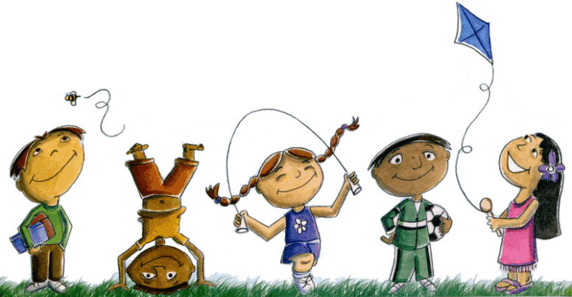 | - Creates an atmosphere of play (social and/or symbolic) with modeling and encouragement
 | - Provides a context for activity through predictable routines, consistent and accessible locations, adequate space for enactment and story creation
 | - Includes the use of props and actions and physical enactment
 | - Adult is flexible and supportive and provides scaffolding between highly directive and participatory role and non-directive encourager and scribe.

